**Project Report: Excel Portfolio Project**

**Background:**  
This project focused on creating a comprehensive and professional Excel-based portfolio to demonstrate advanced data analysis and visualization skills. Using a raw dataset, I transformed it into a polished, interactive Excel dashboard. The project simulated a real-world scenario, allowing me to showcase my ability to clean, model, and visualise data effectively using Excel.

**Task Overview:**  
The objective was to handle a raw dataset and turn it into actionable insights through advanced Excel functionalities. The project involved the following key steps:

* **Data Cleaning:** Addressing inconsistencies and preparing the dataset for analysis.
* **Data Modelling:** Structuring the data with relationships to support meaningful analysis.
* **Dashboard Creation:** Designing an interactive dashboard to present insights in a user-friendly manner.

**Solution:**

1. **Data Cleaning:**
   * I meticulously cleaned the raw data by identifying and correcting errors, removing duplicates, and standardising formats to ensure data integrity.
   * Applied formulas and tools such as conditional formatting and text-to-columns to refine the dataset.
2. **Data Modelling:**
   * Created a date table and established relationships between different tables to allow for streamlined analysis.
   * Used Excel features such as pivot tables and data validation to organise and categorise data efficiently.
3. **Dashboard Design:**
   * Developed a dynamic, visually appealing dashboard using charts, slicers, and conditional formatting.
   * Incorporated key metrics, such as total sales and performance trends, using formulas and measures to calculate insights.
   * Designed an interactive interface that enabled users to filter data by categories, time periods, and other dimensions for deeper insights.

**End Result:**  
The result was a professional, fully functional Excel dashboard that transformed raw data into actionable insights. The dashboard allowed for easy exploration of key metrics and trends through interactive elements. This project highlighted my ability to manage the end-to-end data analysis process, from cleaning and modeling to visualization. It demonstrated my proficiency in Excel as a powerful tool for solving real-world analytical challenges and creating impactful data-driven stories.

**Snapshots of the Project**

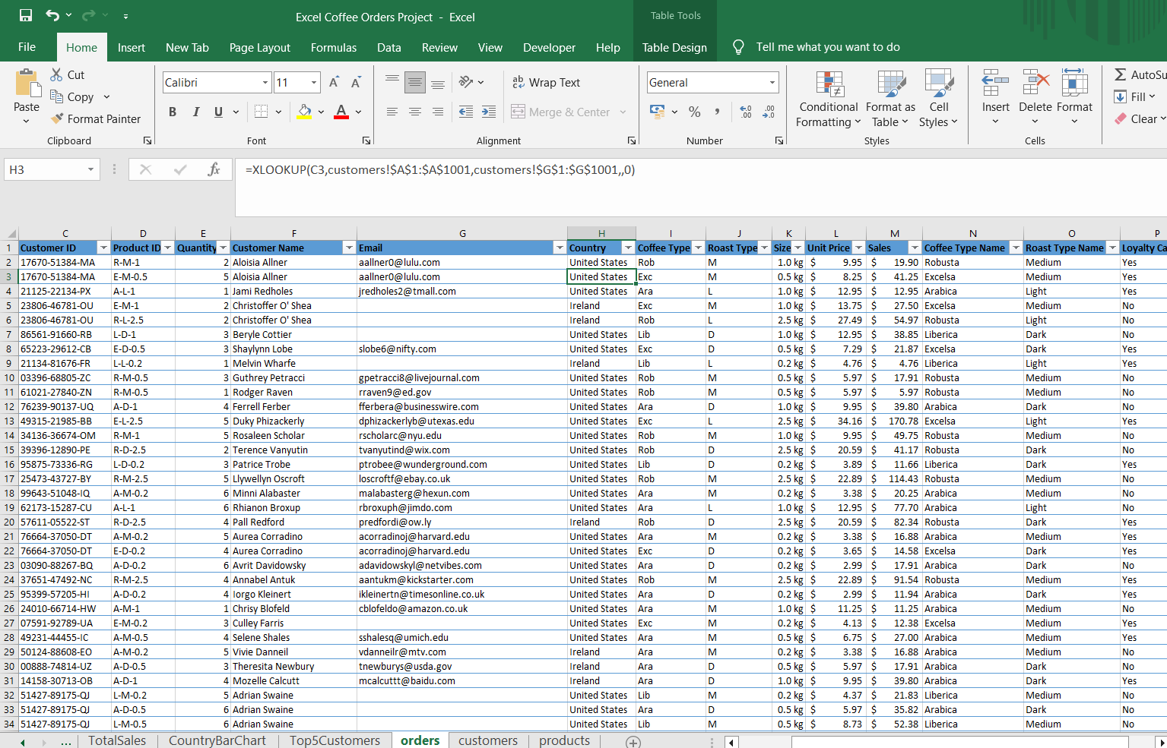

XLookup function used to input data into Orders sheet from Customers sheet

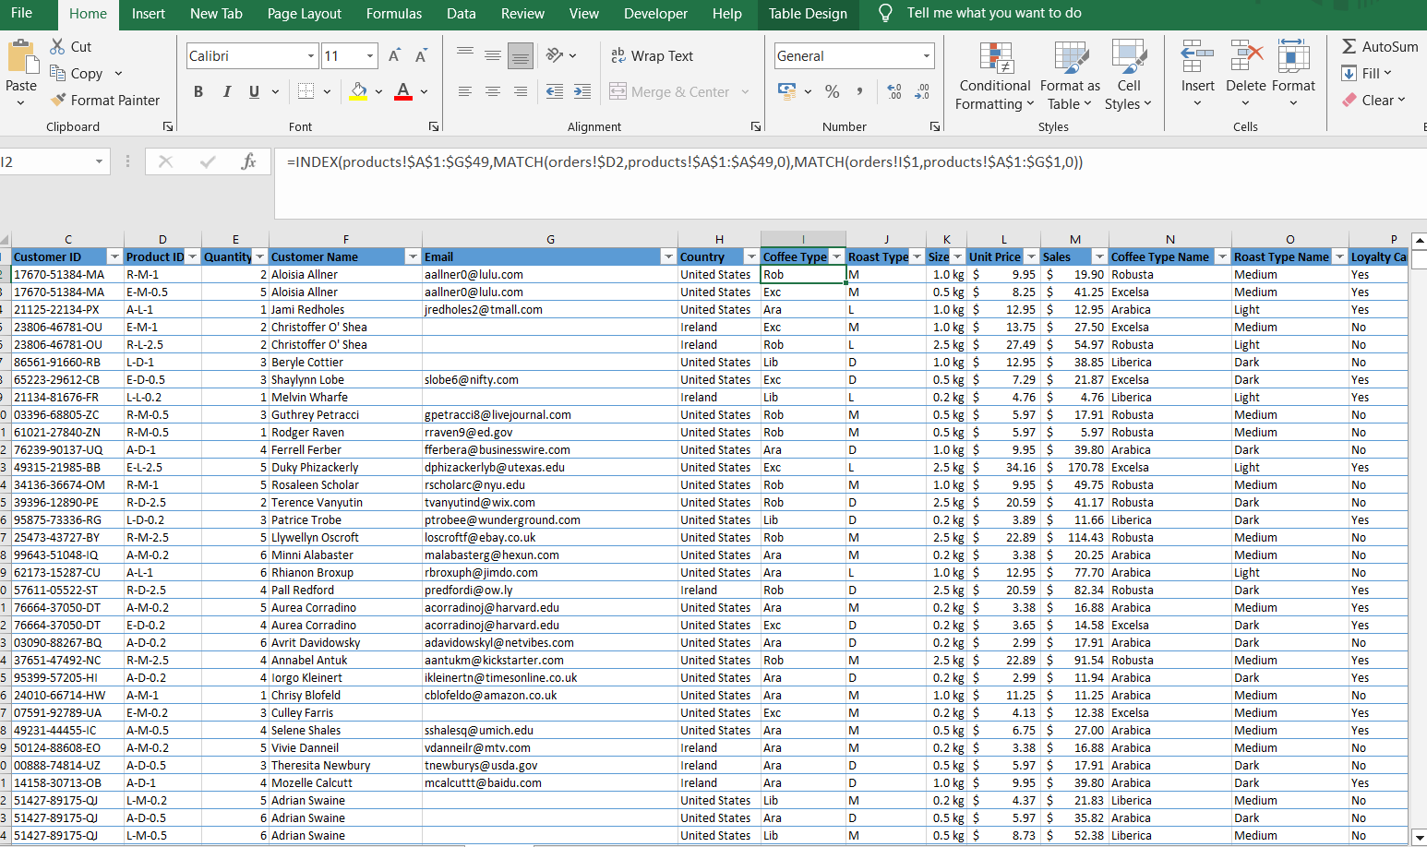

Index and Match function use case to input data from different sheet into main worksheet

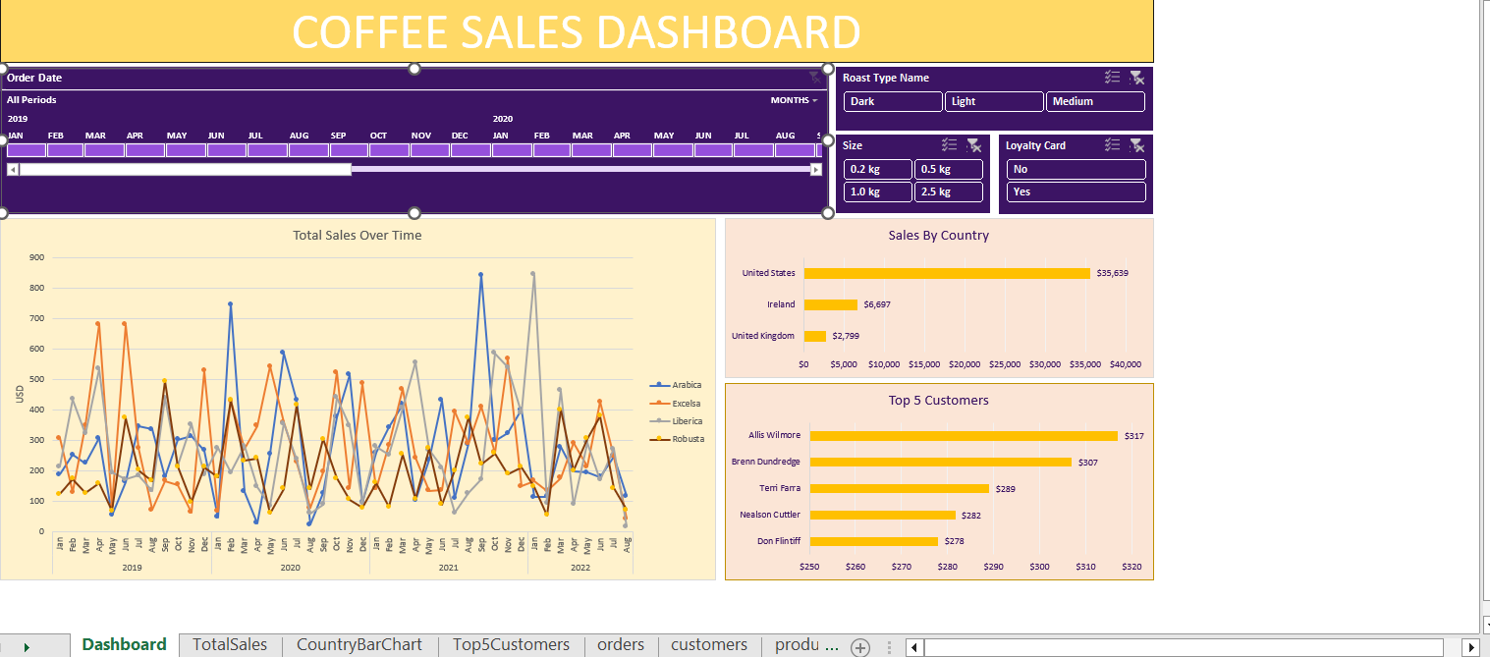

Final Dashboard with all the important KPIs on one page